How to turn PIPESIM results into an R data.frame that can be used to explore results.

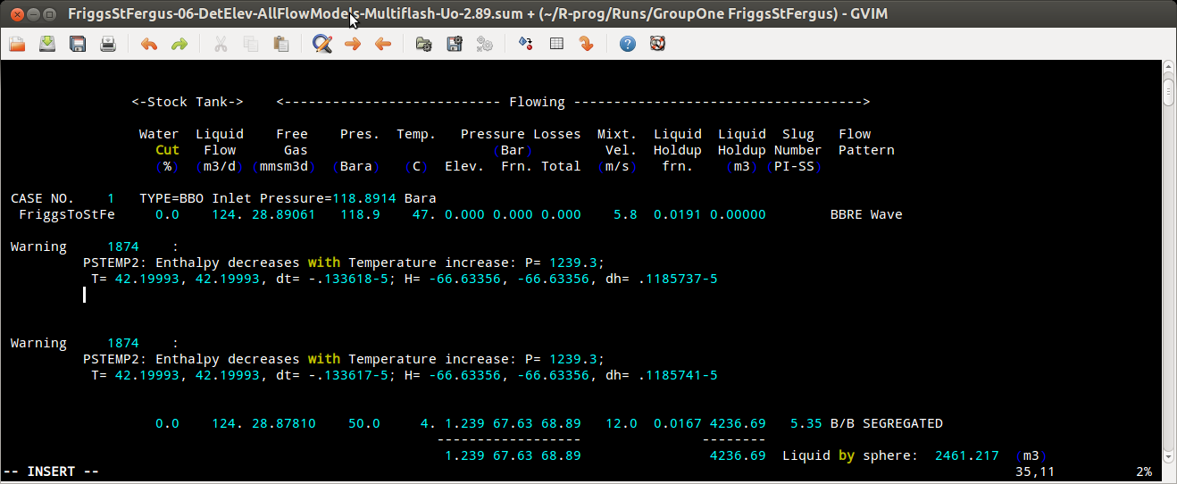
- The results from the simulations are stored in plain text files with the name of the original case file and extension .sum with the format:
- The results can be extracted via a function that transforms the .sum file into a csv file with the information sought in the format:
Group,1,Run,1,ElevProf,detailed,Pset,downstream,FModel,BBO,Pin,118.8914,Uo,2.89,Pout,50.0,Tin,47.0,Tout,4.0,PlossElev,1.239,PlossFric,67.63,LiqHoldup,4236
- The csv file can be read in R as a data.frame
- The data.frame can be used for exploratory analysis.

Parsing sum files:

- Write a function that parses the results of one flow model at a time.

- Write a function that uses the previously written function to walk over the sum file writing to the output csv file with the structure shown in step 2. Each row written corresponds to one run identified in the sum file.

- Write a function that walks all subdirectories looking for files terminated in sum and adding all the cases to the csv file.

The first R function signature:

collectData <- function( groupNo, RunNo, elevProfType, pSetType,
pIn, tIn, lineToParse )
This function is called when a line with the CASE NO. Literal has been found, and the line that follows it immediately below needs to be processed for the pressure and temperature going into the line.
This function calls the function that extracts all the values from the line which shares a very similar structure to the line with the end point values except for the text containing the pipe object name which appears first in the row with input values and does not appear at all in the line with output values.
That function receives a line of text and returns the values water cut, liquid flow, Free gas, Pressure, Temperature, Elevational Pressure Loss, Frictional<Pressure Loss, Total Pressure Loss, Mixture velocity, Liquid Holdup, Slug Number, and Flow pattern:
parseResultsLineSumFile <- function( lineToParse )
It returns all the values as an array of tuples of pairs or similar. This array is to be consumed by the receiving function to populate the line of the csv file being produced.

